Rural Development Programme 2014 -2020
LEADER
Expression of Interest (EOI) Form
Note: This Expression of Interest (EOI) form must be completed as a pre-cursor to an application proper for funding under the Rural Development Programme 2014-2020 (LEADER).
Failure to comply with this form completely will result in a delay in dealing with your Expression of Interest and any further processing of any subsequent application arising for funding under RDP 2014-2020.

Completion Guidance Notes:
- Please complete this form in full (All fields are mandatory) and forward to Laois Partnership along with any additional information you feel may be of relevance.
- Electronic copies of this form can be downloaded from www.laoispartnership.ie and also from the http://www.ahrrga.gov.ie/
- A hardcopy of this form can be obtained from Laois Partnership Offices (Block 2, Ground Floor, County Hall, Portlaoise, Co. Laois)
- A Rural Development Officer will contact you when your Expression of Interest Form has been reviewed.

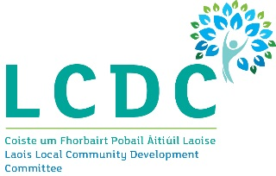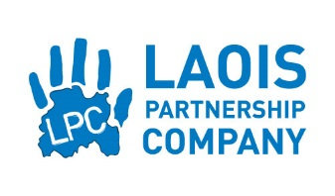
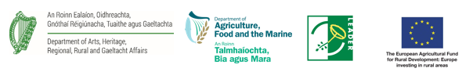

Your Local Action Group (LAG) name: | Laois Community Development Committee
Project Name/ Title | Formulation of a Tourism Development and Marketing Strategy for Co. Laois
Promoter/ Community Group Name | Laois Tourism CLG
Contact Name | Dominic Reddin
Telephone: | 057 86 64218
Email | dreddin@laoiscoco.ie
Address: | Áras an Chontae, JFL Avenue, Portlaoise, Co. Laois
Promoter Type:  Please Tick one | Sole Trader Community Council  Farmer Trust  Formalised Community/ Voluntary Group x Partnership  Company Limited by Guarantee Limited Company  Designated Activity Company Limited by shares Public Body  Registered Charity Private Individual  Registered Cooperative Society
Herd No: (if farmer)
Has Promoter/ Community Group received Leader funding previously? | Yes x  No  Please Tick One
Project Address: | Co. Laois
Level of LEADER Funding Required For Project: | 75% up to €28,000 depending on value of successful tender.
Other sources of funds for project (If any – bank loans etc.): | Current funds will be used to raise match funding.
Brief description of the project:
The potential for tourism development in County Laois is considerable. Compared with several other Counties in Ireland and despite its various attributes, Laois currently ranks amongst the lesser visited places to visit and / or stay both for domestic tourists and visitors from abroad. It is felt, with confidence by Laois Tourism Company, that the development of a cohesive tourism development strategy with a corresponding implementation schedule will help us to reverse this absence of a tourism tradition, achieve a positive foothold in the tourism industry and benefit on an ongoing basis, from a far higher market share of this lucrative sector in the County.

Signed for and on behalf of the Promoter/ Group:
I/ We confirm that the details supplied are true and correct to the best of my/ our knowledge

Name in Block Capitals:

Signature:

Date:

Part of all of the information you provide will be held on computer and hard copy format. This information will be used for the administration of Expression of Interests and producing monitoring returns. LAGs may share information with each other and government departments/ agencies to enable them to prevent fraudulent applications or for detecting crime and to co-ordinate processing of complementary applications. It may also be subject to meeting obligations under the Freedom of Information Act as amended. This policy does not affect your rights and your information will be held as prescribed under the Data Protection Acts 1988 and 2003.

Internal:
EOI Ref ID:
Call Type: (Rolling/ Time Limited)
Main Programme Theme
LAG Office Signature:
Printed name of LAG Officer:
Date form Received from Promoter in LAG:
LAG Date Stamp:

