The Birth of a Vibrant Community
Collaborative Community Engagement to Foster Local Empowerment
“A new support which we never had before,”
. “I would be sitting at home, alone, if it was not for this programme.”
“It helps a lot with my English”
This is the story of how successful engagement with the local community, using a collaborative approach, leads to a more confident, healthier and happier environment.
Under the SICAP 2019 plan, Goal 1, Action 1- Empowering Communities- Laois Partnership Company (LPC) has set out a programme of non-accredited activities which support and develop the capacity of residents and which have a meaningful impact of the lives of people living in areas under SICAP support. Building on predevelopment work in 2018 which identified specific needs of residents and through on-going consultations with them, the programme has been planned and structured to ensure gainful participation.
This SICAP action covers various locations throughout Laois, but, for the purpose of this case study, Mountmellick, was chosen. The aim of the action is to promote community engagement, to capacity build local community groups and to support residents to participate in decision-making structures
“I had few local contacts when I first commenced working in Mountmellick under SICAP 2018”, says Sylvia Rouget, Community Development Worker with SICAP. “It was a new geographical area for me to work. “I started doing house to house calls but, because I was unknown to residents and had not built up any trust, I met with little success. I noticed a lack of community centres within the areas we were working so decided to approach whoever could assist me.
One of Sylvia’s first contacts was Miriam Geaney, Home School Community Liaison (HSCL) Coordinator with Scoil Phadraig Naofa, the boy’s national school of 260 pupils. Miriam was appointed to this role in 2017 under the DEIS Nua banner having previously taught in primary schools for thirty years. Her role empowers parents to be enabled to educate their children to full capacity. She facilitates courses for the parents, conducts home visits and brings parents into school to assist with various projects. The core job of a HSCL, in her view, is to foster relationships between home and school and develop trusting partnerships with parents. “I am an agent of change within communities where there has been generational lack of access to educational progress,” she says.
Miriam is part of a team of three home school community liaison coordinators in Mountmellick who work closely together. In addition to Miriam, Sylvia made contact with the manager of Mountmellick Youth Development Centre which provided support to school children and their families and was a precursor to Mountmellick Youth and Family Resource Centre (MYFRC) which is a community-based centre that provides a range of youth family and community services for the residents of Mountmellick and surrounding areas and which opened its doors in 2019.
“A collaboration was formed,” says Sylvia. We all had the same aim to capacity build families to ensure a healthier, happier and more confident community and we were all committed to pooling our resources and avoiding duplication of services and supports.
This practical approach led to the 3 DEIS schools in Mountmellick working closely with the community development worker and, in time, other agencies were approached. The lack of community buildings within identified estates meant that activities took place in the local schools and in Laois Education and Training Centre (formerly Youthreach) which is run by Laois Offaly Education and Training Board (LOETB) and is located close to many of the Local Authority housing estates in Mountmellick.
Participants were targeted by the respective agencies and there was an “all are welcome” policy to ensure inclusion of all age groups and not just parents of the school children. Tutors are funded by Laois Partnership and the LOETB and costs of materials are met by Laois Partnership. Other agencies contributing to the collaboration include HSE, Healthy Ireland, Laois Co Council, the Prison Services, Laois Sports Partnership and the Gardai.
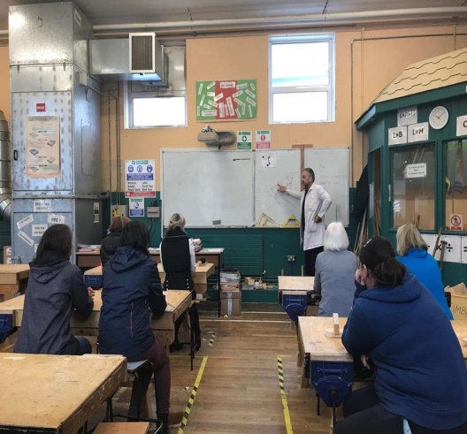
Following consultations with residents, it was decided to offer a range of short duration activities in 2019 and, to date, these have included Haircare, Woodwork, First Aid, Mindfulness, Trampoline, Book Club (including magazines for those with literacy difficulties), mental health awareness workshops and the setting up of a walking group. Focus is on enjoyment and healthy living through education and course topics are chosen to suit the needs of the participants. Over 20 residents, both men and women, are presently taking part in the programme.

Woodworking Training

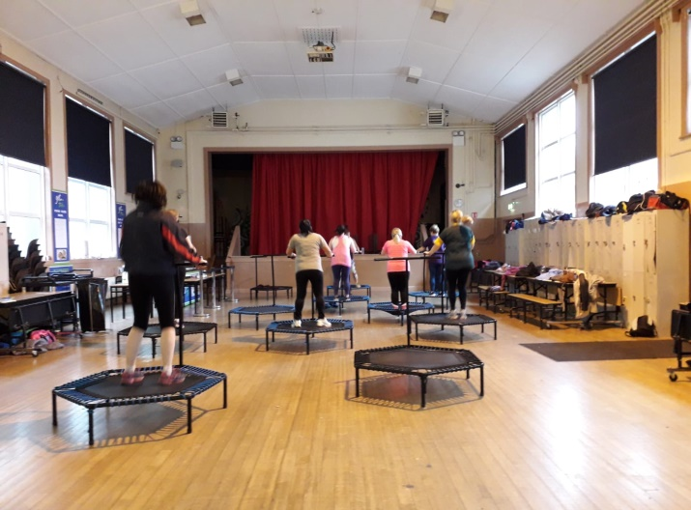
Trampoline Class – Jump for Joy!

In addition, in May 2019, the first Laois “Use your head, not your fist” workshop was held in Mountmellick Community School and delivered to over sixty 5th Year students. This interactive workshop was organised by Laois Partnership and was the first workshop held by the Prison Service in Laois in a secondary school. The success was such that parents are now requesting this to be rolled out on a yearly basis in all schools in Laois.
As the programme evolved, sporting activities during the summer were organised in the targeted estates for the children. Parents were invited to sit on the green for an informal cold drink and chat. All who engaged were encouraged to bring a neighbour, friend or family member to the next workshop/meeting/cup of tea/chat on the green. “The idea was to empower participants to engage members of their own community,” says Sylvia. “A cup of tea is the start of a conversation, this is the essence of community development. We are all equal in front of a cuppa.” Doors to door calls to encourage engagement were also carried out in the identified Small Areas.

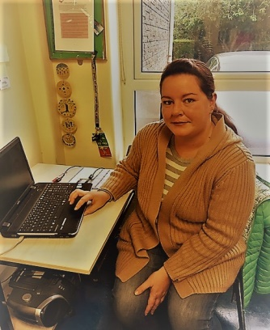
Engagement
32 year old, Tracey Storey endorses what Sylvia says. “The cuppa and the chat are so important as we get to know each other,” says Tracey who is a single mum and has been living in Mountmellick with her nine year son Riyadh for the past five years. “I would be sitting at home, alone, if it was not for the activities programme. I have experienced such loneliness and depression and feel so much happier since I started the programme. I know that my self- esteem has improved.
I am now taking part in a different activity four days a week while Riyadh, who is autistic, attends school. I walk on a Tuesday, do woodwork on Wednesdays, cookery on Thursdays and zumba on Fridays. It takes me out of the house, I have made friends and I have built up such a trust with Sylvia and Miriam that I can ask them for advice and support in all areas of my life. They gave me character references when I was moving house – I wouldn’t have got the house without their help. Sylvia and Miriam have built up a comprehensive pool of contacts in support agencies and this is proving invaluable to participants of the programme.”
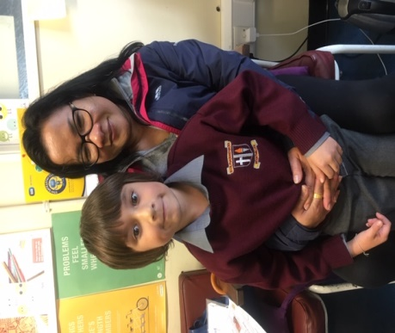
Piyawadee Cox is from Thailand and married an Irish man in 2007. “At first we lived in Newbridge and moved to Mountmellick nine year ago,” she says “ I knew nobody and stayed in the house most of the time but since the children started school, I have more time” Piyawedee has a daughter of 11 years attending the girls national school and Joseph, aged 7 is in Scoil Phadraig Naofa. So far Piyawadee has taken part in hairdressing, cookery, first aid, mindfulness, yoga and DIY courses. “I love coming. I talk to people and have made friends. It helps a lot with my English. I hope to start woodwork and join the walking group.”
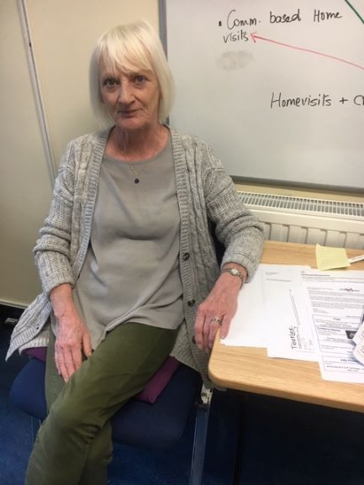
Grandmother Rose Comerford has two grandsons in the boy’s national school. “I came to the programmes by default,” laughs Rose. “My daughter had planned to join the programme but she got a job so I mind the boys.” Sadly both Rose’s father and father-in-law died in 2017. “I was very down after that.” Up to February 2017, Rose had been working in retail and was meeting people every day. “Now, I found the days were dragging. I’d shop for the week and didn’t want to go out after that. But since I started the programme, my attitude has completely changed, “I feel so different now,” says Rose, 59, who has lived in Mountmellick all her life. “I love the courses and there is a great element of fun through them. I got to know people and enjoy every day.”
Rose, who was previously a children’s nurse, particularly enjoyed the first aid course. “We got a certificate on completion and this gave us a feeling of achievement. The DIY course was so interesting, we learnt how to change plugs, fit an outside tap, sort out U bends and fix the washing machine.” Rose has done meditation for years so found the mindfulness course of great benefit. “It got people talking, sharing their problems and seeking support and friendship from us all. I had stopped walking but the Tuesdays walks now motivates me to get up and out”
Rose now plans to join the book club and will take part in the “Irish for Parents” sessions which are being run in the school and “which will help me with the boys’ homework.” The programme has benefitted me both mentally and physically. We have a chat and a laugh, Coffee mornings have been arranged and this gives up an opportunity to air a problem and get support. Sylvia and Miriam go out of their way to help us. We trust them and feel we could ask them anything. This is a new support which we never had before.”
Collaboration
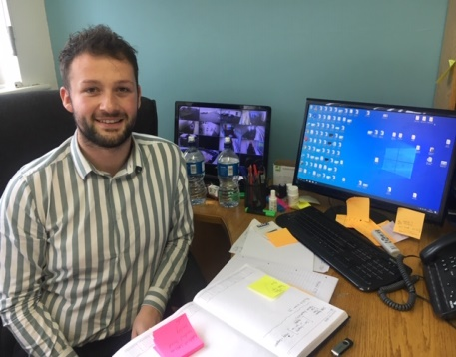
Darryl Griffith has been Centre Manager of LOETB Further Education and Training Centre, Mountmellick for the past one and a half years and linked up with LPC to encourage communities to come into the centre. “We needed to get a community programme so people aren’t sitting at home in isolation. This SICAP programme offers non accredited courses and these courses will entice people to the centre where they may progress to NFQ. They provide an opportunity for local people to come together, they are very accessible and they are free. The social element is very important for them. We are able to share our resources, including tutors and some of our past Youthreach students including members of the Travelling Community have accessed the programme. Sharing knowledge and planning with the other agencies has been hugely beneficial to all the agencies,” says Darryl.
John Morrell has been Principal in Scoil Phadraig Naofa for the past twenty years. “This programme provides inclusivity in its full meaning,” says John. “It provides support for children and parents outside the school curriculum. We are partners in education. – not just for children but for parents – school attendance is not just about turning up on the day but also about establishing an environment where children and parent can strive and thrive.”
“We plan to build on the success of the programme in Mountmellick and use this method of engagement and collaboration as a means of building up trust and resources in other areas throughout Laois,” says Catherine Cowap, Social Inclusion Manager with Laois Partnership Company.

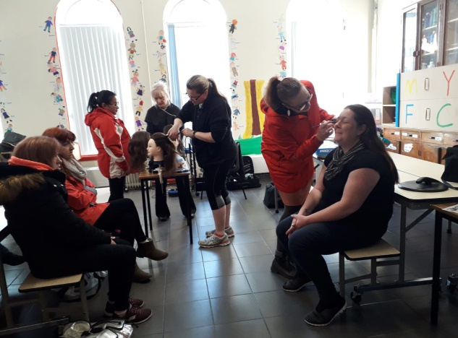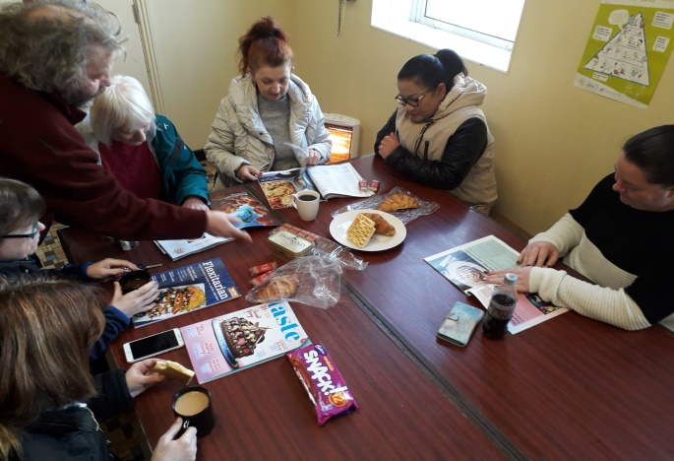
This action is a great example of work contributing to the horizontal principles of community development by focussing on gender equality and anti- discrimination practise, by applying community development approaches to achieve the participation of disadvantaged and marginalised community in wider context and by developing collaborative approaches with stakeholders.
The programme has been instrumental in the birth of a more vibrant community in Mountmellick where residents feel that their self- esteem and confidence is flourishing. It has provided a strengthened sense of community amongst the participants and there has been increased participation in social, cultural and educational activities among SICAP target groups. As collaboration, it has ensured that resources and supports are shared and it has avoided any duplication of services within the area.
There has been much learning from this programme and the unlimited value of collaboration has probably been the main one. The Community Development Worker piggybacked on the successful work already undertaken by the HSCL coordinators where an environment of trust had been established with families. The schools, local sports complex and LOETB are very willing to use their facilities to accommodate the programme and this has saved rental costs of premises for SICAP. Other resources have also been pooled to provide best use of available funding. The financial contribution from SICAP of €3,000 is far outweighed by the value of staff time spent with both the participants and collaborators.
Another area of learning of the programme has been the lack of initial engagement when the Community Development Worker attempted to identify potential participants by calling house to house in an area in which she was unknown and how important it is to develop credibility in the community and to accept that it takes time.
For the participants, the programme provides access to informal learning in a friendly and welcoming environment and provides opportunities to progress to further training through the SICAP or other agency programmes. Progression for the School Home Community Liaison Coordinators will mean increased engagement with parents of school children and increased collaboration with relevant agencies. For the SICAP community development worker, progression means bringing this successful template of work to other areas in Co. Laois which have not yet benefitted from SICAP.

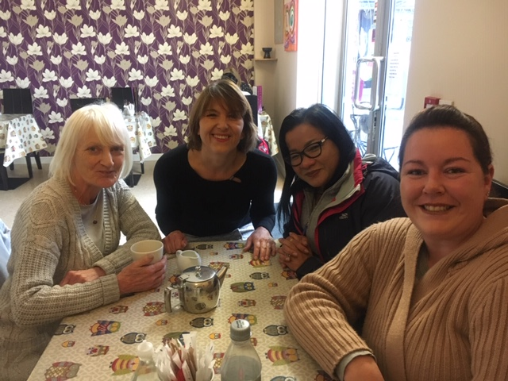
From l to r Rose, Sylvia, Piyawadee and Tracey enjoying a cuppa after the interviews

